CERTIFICATE OF COMPLIANCE– REACH-SVHC

Company Address: 19F/20F, Parkway Center, No.121, Dong Men Zhong Lu,
Chang An, Dongguan, Guangdong, PRC.

Contact Person: Jack Xiong
E-mail: jack.xiong@icape.cn
Telephone: +86 0769‐89997000

This letter is to assure that all the PCB supplied by ICAPE in compliance with the EU REACH directive on the restriction of the use of SVHC (Substance of Very High Concern), except the surface finishing is HASL SnPb PCB. We declare our products contain less than the limit of permitted content specified in REACH, The latest 247 substances restricted per the REACH directive was last updated: Jan. 21, 2025. Please refer to the following for the most current candidate list of substances: http://echa.europa.eu/web/guest/candidate-list-table.

Name: Jack Xiong

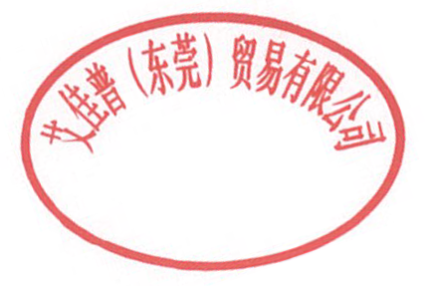
Signature: 

Title: QE team leader

Date: 2025/2/13

