CERTIFICATE OF COMPLIANCE- EU RoHS Declaration
Company Name: ICAPE
Company Address: 19F/20F, Parkway Center, No.121, Dong Men Zhong Lu,
Chang An, Dongguan, Guangdong, PRC.
Contact Person: Daniel Xu / Luffy Zhu
E-mail: daniel.xu@icape.cn / luffy.zhu@icape.cn
Telephone: +86 0769‐89997000
This is to certify that all parts (PCB) supplied by ICAPE meet the requirements of the current RoHS 3 DIRECTIVE 2015/863 and its subsequent amendments.
The part delivered to customer can meet ROHS requirement as below (10 substances):
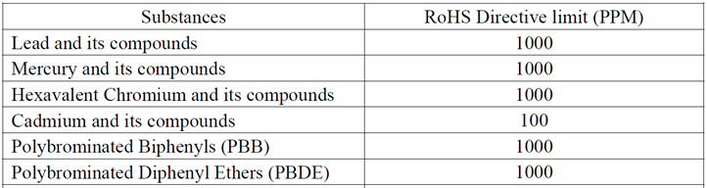
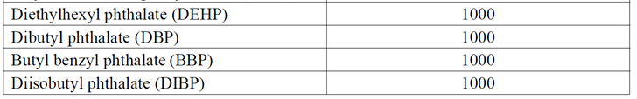

(Remark: except the one that surface finishing is HASL with Lead.)

Name: Daniel Xu Title: Engineer

Signature: 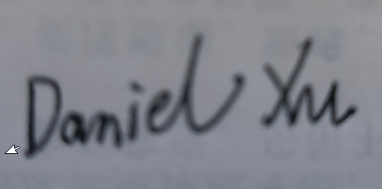 Date: 2024/3/7

